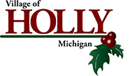

 

April 2023

To Whom it May Concern:

It is without hesitation that I write this letter in support of application for the Bridge Builder Grant. As Village Manager, I fully support, and look forward to working with the Holly Downtown Development Authority on this project. Funds from the grant will help make our historic downtown more attractive for people to shop-dine-stroll as they enjoy our local businesses. This grant will enhance our capabilities, and accomplish things that we would normally not be able to accomplish due to our limited budget, and difficult fiscal period we just went through due to COVID related issues and our devastating fire this past Summer.

I want to thank you for your consideration of our community for these funds. Please do not hesitate to contact me if you should have any additional questions.

Sincerely,

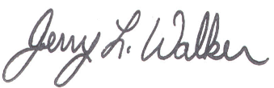

Jerry L. Walker,

Village Manager

Village of Holly