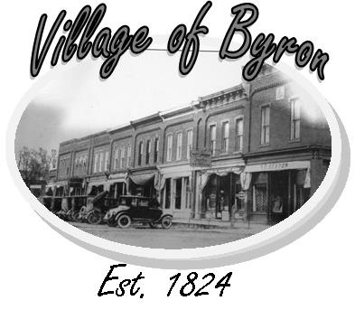
Village of Byron Downtown Development Authority 146 S. Saginaw, Byron MI 48418 810-266-5090
Rebuilding For Our Future
www.byronmi.org

April 2023

Dear Grant Review Committee:

I am writing to express my strong support for the proposed mural project in our town of Byron, Michigan at the Village Municipal Building adjacent to a new pocket park. As Co-Chairperson of the Byron Downtown Development Authority, this project has the potential to bring significant benefits to our community and strengthen the area’s prevalence as a recreation destination along the Shiawassee River, a designated National Water Trail. I am thrilled to have secured local artist Kevin Hooley with FKSigns in Byron to design and work on the mural!

This pending mural will be designed to highlight Byron’s history and rural community and give our village a sense of pride and resiliency in the aftermath of rebuilding after a devastating fire in our downtown. The mural in the new park will support larger community and economic development efforts. Byron is blessed with having the Shiawassee River flow through it, and the pocket park and mural will provide a place to enjoy the local recreation facilities. The application to MML Main Street Microgrant to support this project would allow us to show off the beautiful history of our village in a prime downtown location.

The Byron DDA is excited to be not only support a local artist, but to provide a new attraction for tourists and visitors; we can attract more people to our town and stimulate local businesses. Small shops and restaurants would benefit from increased foot traffic, and the development of this project would serve as a focal point for community events and festivals.

As Co-Chairperson, I will work closely with the Village Council, local businesses, and community members to ensure that the boardwalk is built in a way that benefits everyone – we are committed that all elements of the mural be representative of all members of our community so that we can all be rejuvenated and exhilarated as we Rebuild for Our Future. I urge you to join me in supporting this exciting project for our town!

Best Regards,

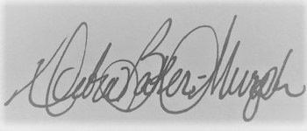
Debra Baker-Murph
Co-Chairperson, Village of Byron DDA
Debra96Baker@hotmail.com

