April 15, 2023

To whom it may concern,

On behalf of the City of Plymouth, I am happy to offer this letter of support for the City of Plymouth’s Downtown Development Authority Main Street grant application “Central Parking Deck Garage Mural”. The partnership between the Plymouth DDA and artist Lisa Littell to create a painted mural to activate an unutilized area near the main Downtown Plymouth parking area is a project that will enhance the artistic ambiance and reflect the City’s cultural values.
The Central Parking Deck Garage Mural aligns with the Plymouth DDA’s five-year Strategic Plan task of “improvement of alley ambiance and business engagement via artwork to enhance appearance”. With additional funding, another sterile area near the Central Parking Deck to Penniman Avenue in the heart of Downtown Plymouth can be transformed into an outdoor art piece that will make the community proud.
Thank you for your consideration of this grant proposal. We are excited about the potential of activating additional untapped areas of our downtown with wonderful works of art very soon.
Sincerely,
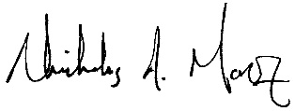
Nick Moroz
Mayor, City of Plymouth

